**DI GOOD PLACE DEM**

**USER MANUAL**



*Di Good Place Dem Kiosk User Manual*

*Documentation version: Version 1.0*

*Date published : 24/11/2019*

*Issuing organization: University of Technology Jamaica*

Table of Contents

Introduction 3

Information for use of the documentation 4

Kiosk System Requirements 4

Hardware requirements 4

Software requirements 4

Concept of operations & Procedure 5

Error messages and problem resolution 7

Glossary 8

Creators Information 9

# Introduction

With the increase of Airbnb experiences available, the Jamaica Cultural Development Agency working with the Jamaica Tourist Board and Sangster’s International Airport decided that tourists should have easy access to the information of the various attractions in Jamaica and get the opportunity to learn Jamaica dialect in the process. This they believe could be done through a kiosk system. This kiosk system is a wonderful opportunity to re-engage our linguistic culture and visitors and returning residents can engage in using the Kiosks during their waiting times. The system will take as input a series of Jamaican Creole (Patois) statements and produce a listing of recommended places.’

Users can search for attractions in Jamaica by typing in “Gimmi all a di place dem inna” and the system will readily display a listing of places, For Example “Gimmi all a di place dem inna Kingston” and the system will display all attractions in the parish of Kingston. They can also find the cheapest attraction and look up Jamaican creole phrases among other features

# Information for use of the documentation

## Kiosk System Requirements

### Hardware requirements

Minimum system memory: 4 GB

Minimum available hard drive space: 10 GB

Minimum CPU architecture: 4 cores

### Software requirements

Operating System (64-bit only) -

Windows 7 Requires Service Pack 1 and Microsoft updates KB2533623 and KB3033929

Windows 8

Windows 8.1

Windows 10

Windows 2008 R2

Windows 2012 / 2012 R2

Windows 2016

Windows Installer - 4.5 or higher

# Concept of Operations & Procedure

Home Screen – Where User can choose the type of user they are by entering the number of the selection

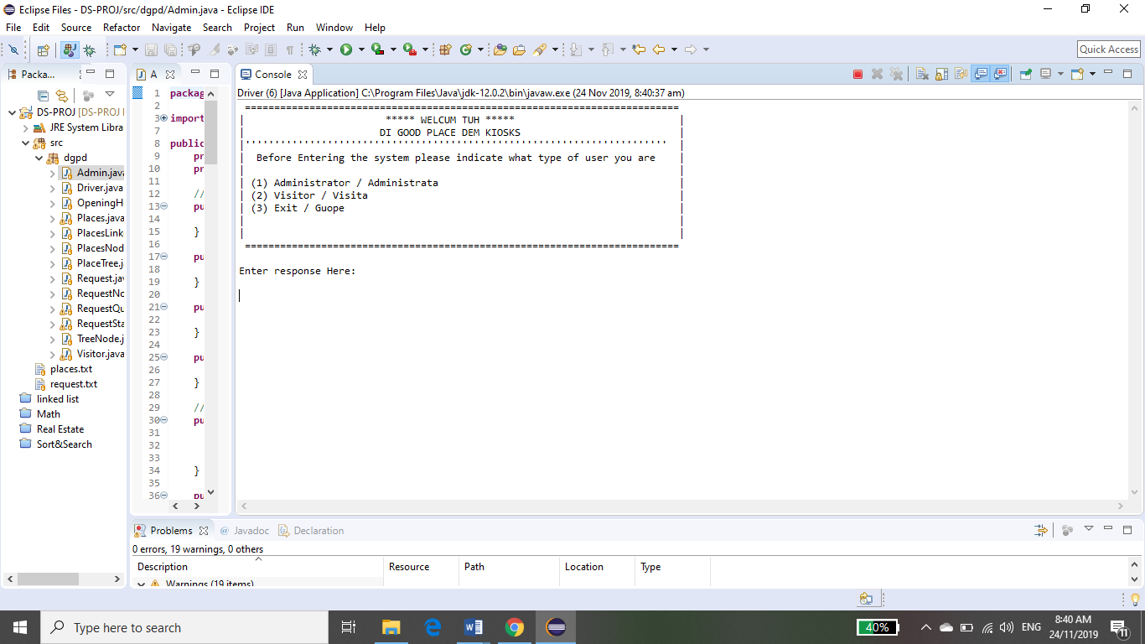

Navigation- For the entire system users can navigate by selecting the corresponding numbers beside their selection, as seen below and the system will display various outputs corresponding with each selection

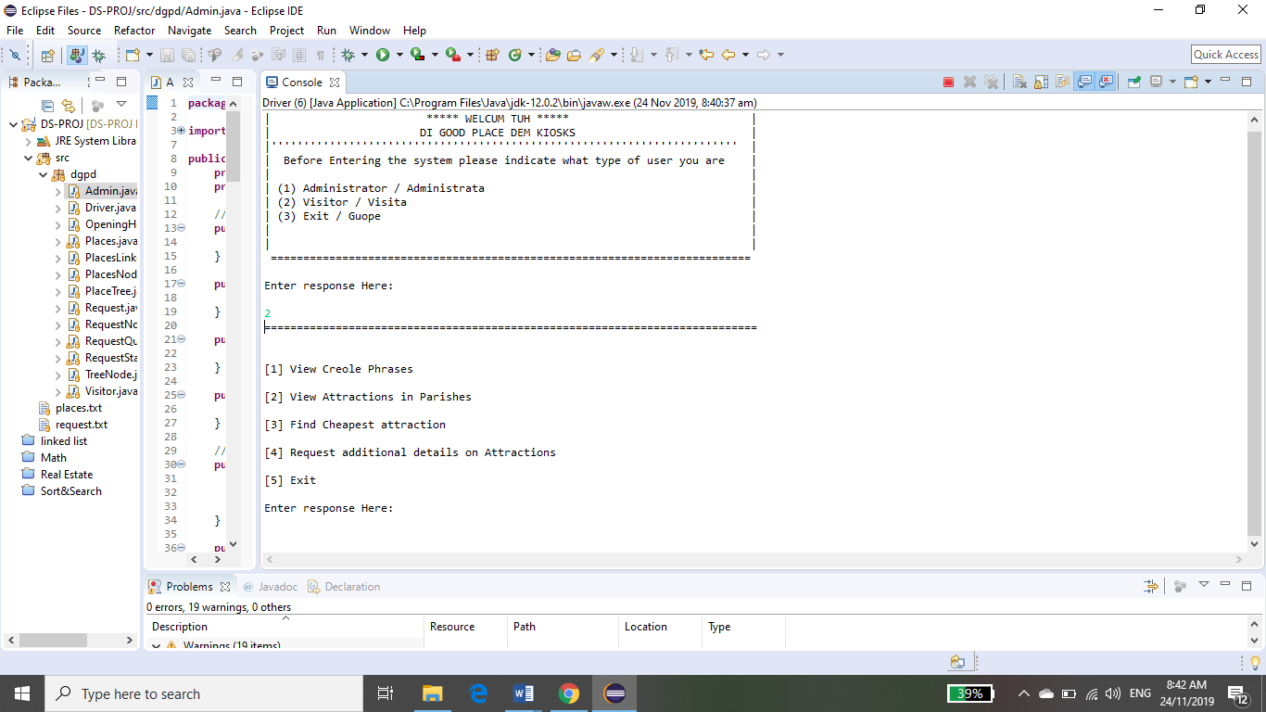

Below is a sample demonstration of the output of the system if users wanted to see a listing of creole phases.

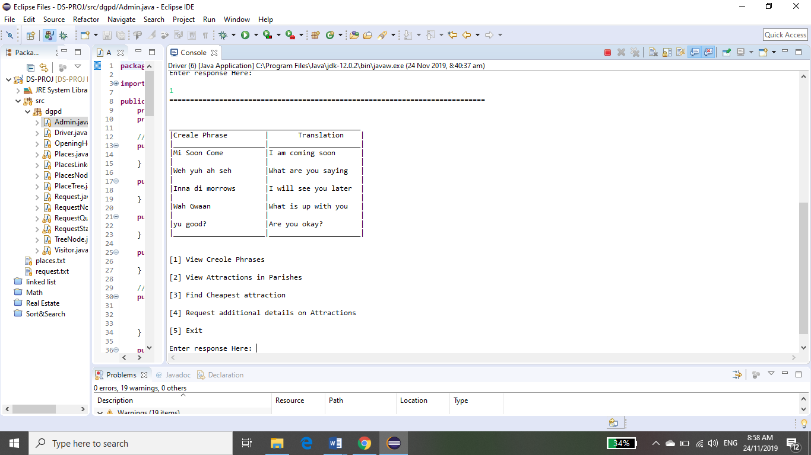

# Error messages and problem resolution

In the Case of error users will be given on-screen instructions and the option of retrying the selected option. As see below the user entered the response 34. However, 34, is not in the list of options, thus the system displayed an appropriate message and gave the user the opportunity to try again.

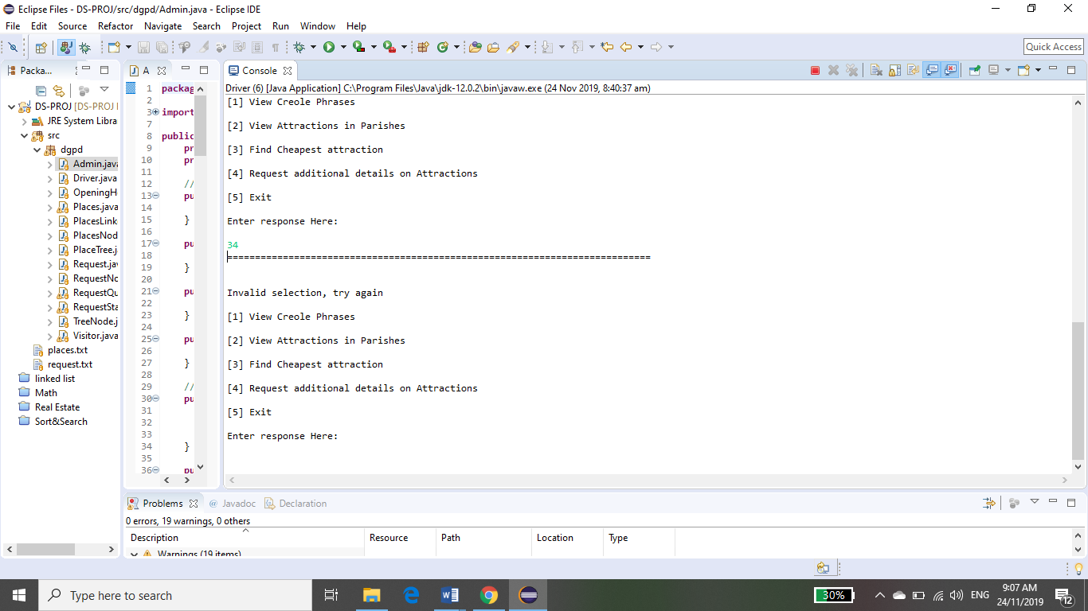

NB: This system may crash due to a flaw in design overlooked by the creators, but if that should occur, users may simply exit and re-enter the system again.

# Glossary

System requirements- To be used efficiently, all computer software needs certain hardware components or other software resources to be present on a computer. These prerequisites are known as system requirements and are often used as a guideline as opposed to an absolute rule

Operating System- An operating system is system software that manages computer hardware, software resources, and provides common services for computer programs.

# Creators Information

Roxanne Meeks- 1700001

Bernard Smith -1703248

Rasheed Walcott- 1701469